React
Global State & Auth Integration




Table of Contents

- Props drilling
- Global State
- Protected Route

Prop Drilling


When Data Needs to Be Used by Multiple Components?

- In React applications, we often have data that needs to be shared and accessed by multiple components throughout the application.
- Logged-in user information
- Application theme (Dark Mode / Light Mode)
- Application language settings
- Shopping cart data
- Notifications


Props

- In React, data can be passed from a parent component to a child component using props.
- Props allow components to share information and make applications more dynamic and reusable.
- They are one of the fundamental mechanisms for component communication in React.


Prop Drilling

- Prop Drilling is a situation where data must be passed through multiple intermediate components solely to reach the component that actually needs it.
Impact of Prop Drilling:
- The code becomes longer and more repetitive.
- The application becomes harder to maintain.
- Debugging becomes more difficult.
- It increases the overall complexity of the application.


Prop Drilling

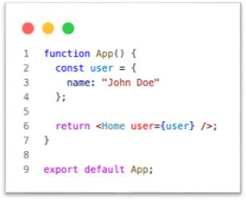
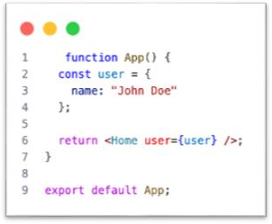
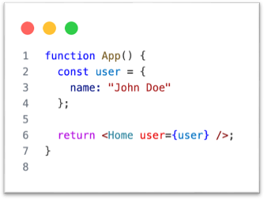

Global State


Global State

- Global State refers to data that is accessible and shareable across the entire application, regardless of the component hierarchy. Unlike local state, which is confined to a single component, global state allows different parts of your app to "t alk" to each other through shared information.
Common Use Cases:
- User Authentication: Keeping track of logged-in user details.
- Theme Settings: Toggling between Light and Dark modes.
- Shopping Cart: Managing items added to a cart across different pages.
- Localization: Switching application languages on the fly.
- Notifications: Managing global alerts or toast messages.


Popular State Management Solutions

- When building React applications, you have several powerful options to manage global state:
- Context API: A built-in React feature perfect for low-frequency updates (e.g., themes, user sessions) without needing external libraries.
- Redux: The industry standard for large-scale applications. It provides a robust, predictable container for complex state management using actions and reducers.
- Zustand: A modern, lightweight, and fast state management solution. It is becoming a favorite for its simplicity and minimal boilerplate.
- Recoil: Developed by Meta, it uses an "atom" and "selector" approach to provide highly granular state management that feels natural within the React component tree.


Context API

- Context API is a built-in feature in React designed to solve the "Prop Drilling" problem. It allows you to share data across the component tree without having to manually pass props down through every single level of components.
Key Benefits:
- Centralized State: It provides a way to create a global state that can be accessed by any component that needs it, no matter how deep it is in the tree.
- Cleaner Code: By eliminating the need to pass props through intermediate components that don't actually use the data, your code becomes more readable and maintainable.
- No External Dependencies: Since it is built into React, you do not need to install any extra libraries.


Context API

- Create folder context
- Create file context/StudentContext.jsx
- Create file context/AuthContext.jsx
- Link Github https://github.com/arip86/fullstackweb2026/blob/global-state/myapp-frontend/src/components/StudentContext.js

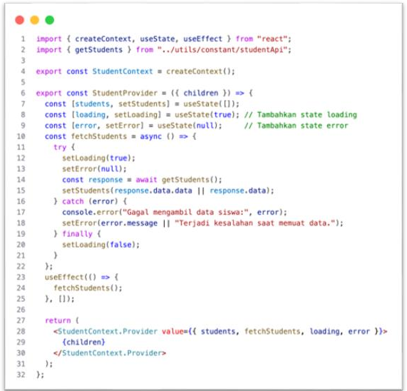
StudentContext

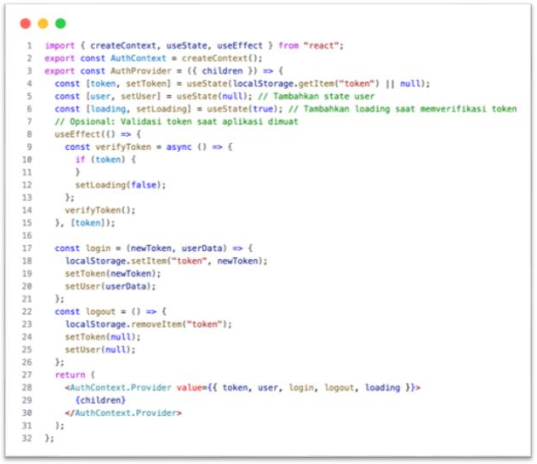
AuthContext

Refactor

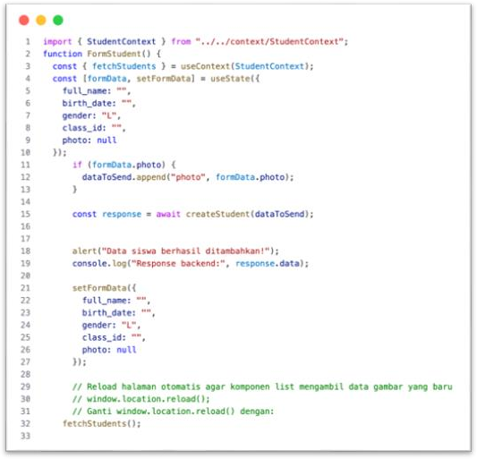
FormStudent.jsx

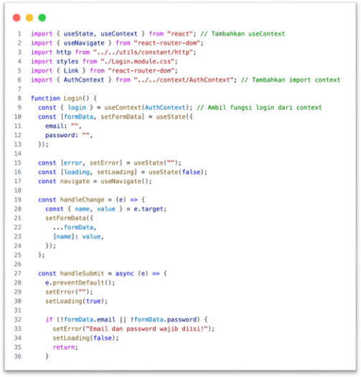
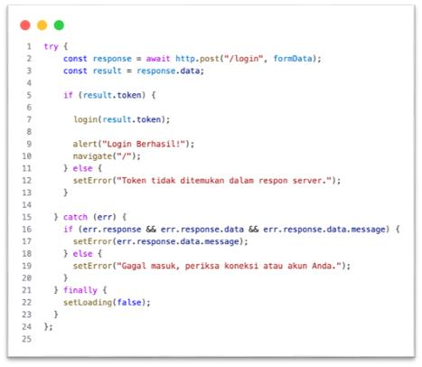
Login.jsx

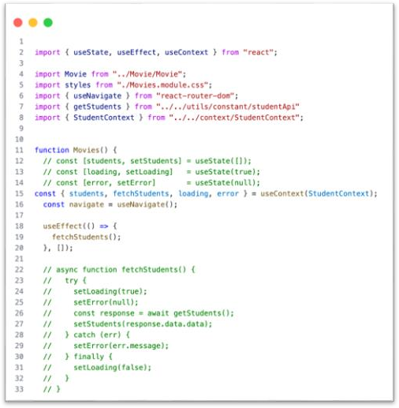
Movies.jsx

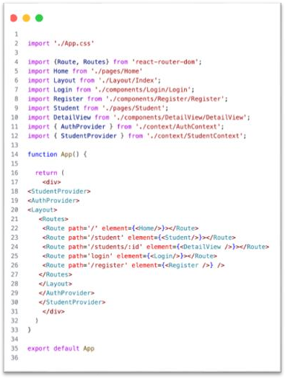
App.jsx

Protected Route


Protected Route

- In web development, Protected Routes (or Private Routes) are a security mechanism used to restrict access to specific parts of an application based on a user's authentication or authorization status.
- Think of Protected Routes as the "Gatekeepers" of your application's navigation.
- Create file ProtectedRoute

ProtectedRoute
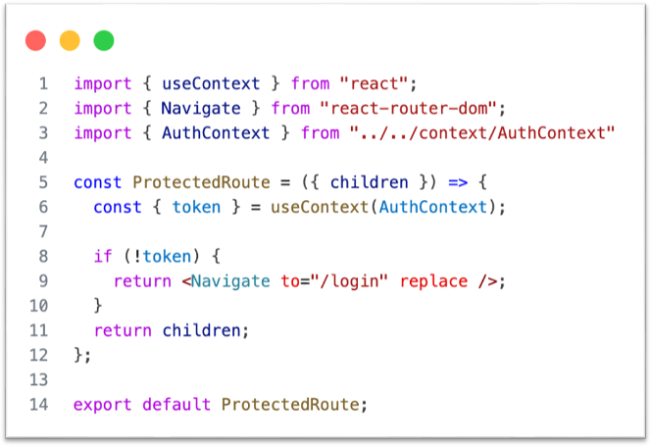

Refactor

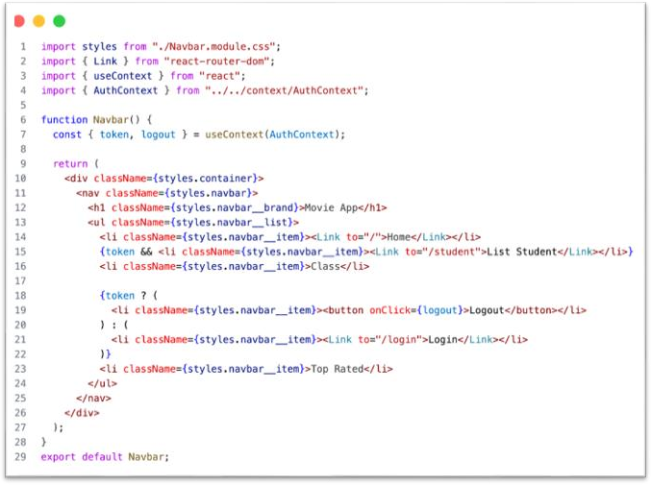
Navbar.jsx

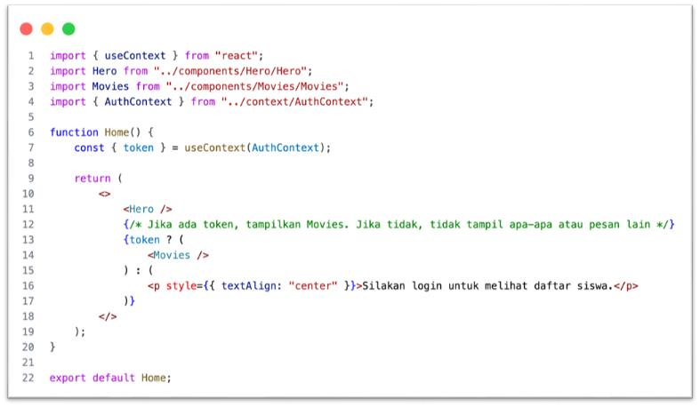
Home.jsx

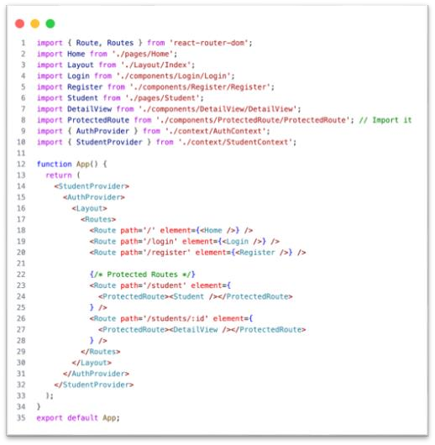
App.jsx

QnA


Sprint 13

- Fokus Sprint 13 adalah mengimplementasikan mekanisme autentikasi pengguna secara end-to-end pada sisi frontend dan menerapkan Global State Management untuk menjaga konsistensi data aplikasi tanpa perlu melakukan refresh halaman.
- Implementasi Global State Management (Context API)
- Autentikasi Pengguna (Frontend)
- Proteksi Rute (Protected Routes)
- Upload source code project ke GitHub
- Kumpulkan screenshoot ke asisten dosen masing masing kelompok

Thanks

